Database Log

* **18/05/2018**
* Created the o2you database on phpMyAdmin.
* Created the users table to store the website’s user data.
* 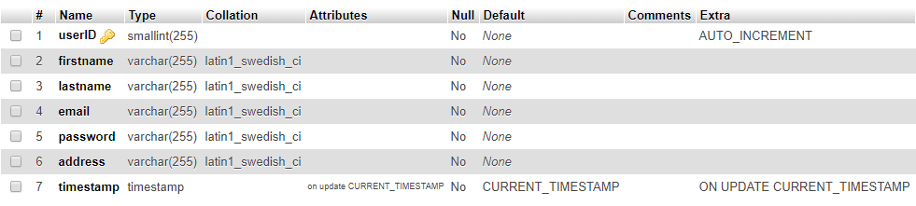Added 7 different fields that will be needed to be filled out during registration.
* **23/05/2018**
* Implemented the script needed to input the data from the html registration form.
* Tested the table to check if the data is inputted correctly (it works).
* Tested the login to check if its reading from the table properly (it works).
* **1/05/2018**
* Test if update profile updates the user details in the table properly (it does).
* **6/06/2018**
* 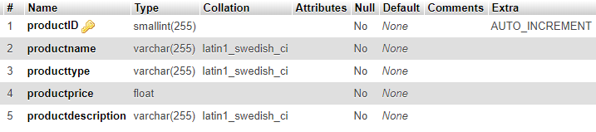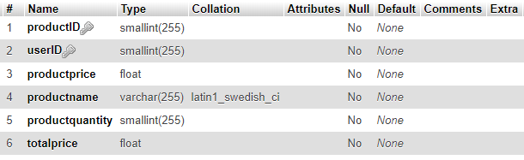Created the Sales, Cart and Products table and its columns. (images are from a later date)
* Deleted the sales table as it is no longer needed.
* **13/06/2018**
* Added foreign keys to the cart table.
* **15/06/2018**
* Added dummy data to the user table. Encountered problem with timestamp (would cause no date, or same date).
* Fixed timestamp problem by normalizing the data in excel. Adjusted formatting of time.
* **29/06/2018**
* Removed “productdescription” from product table, redundant field as it won’t be used on the website.
* **4/07/2018**
* Removed the cart table as it is now redundant.
* Added the productimage column to the product table, now every product will have a link (eg “/jars/jarS.jpg”) to the image in the file directory. The php code on the website will grab this link and display the corresponding image on the website.
* Modified the database relation image to fit the new design.